S:\Documents\Admin\Printed Material\Current Logos\bchfh 2 color.tif

**2018**

Blount County Habitat for Humanity

Homeowner Services Department

2018

Partnership Manual

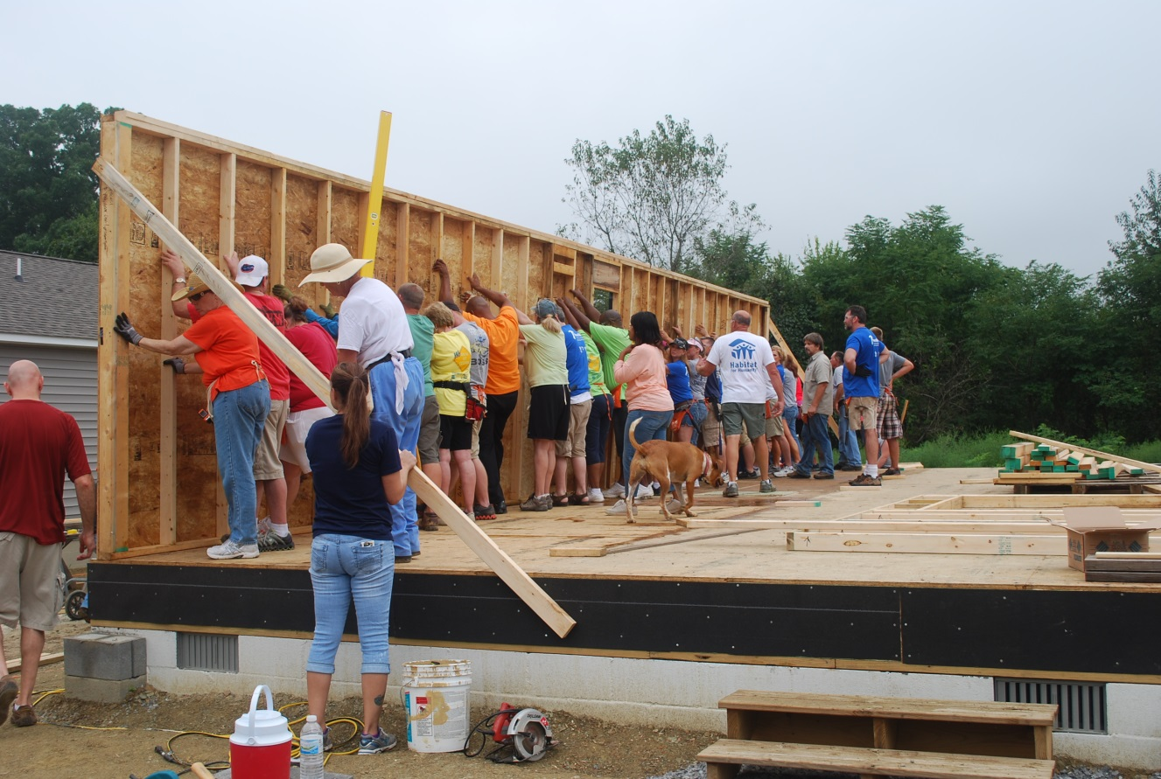

Blount County Habitat for Humanity is an equal opportunity builder and complies with the Federal Fair Housing Act in the marketing, sale, and purchasing of properties. All qualified applicants will receive consideration for homeownership without regard to race, color, national origin, religion, sex, familial status, marital status, income from public assistance, handicap or because a right was exercised under the Consumer Credit Protection Act .



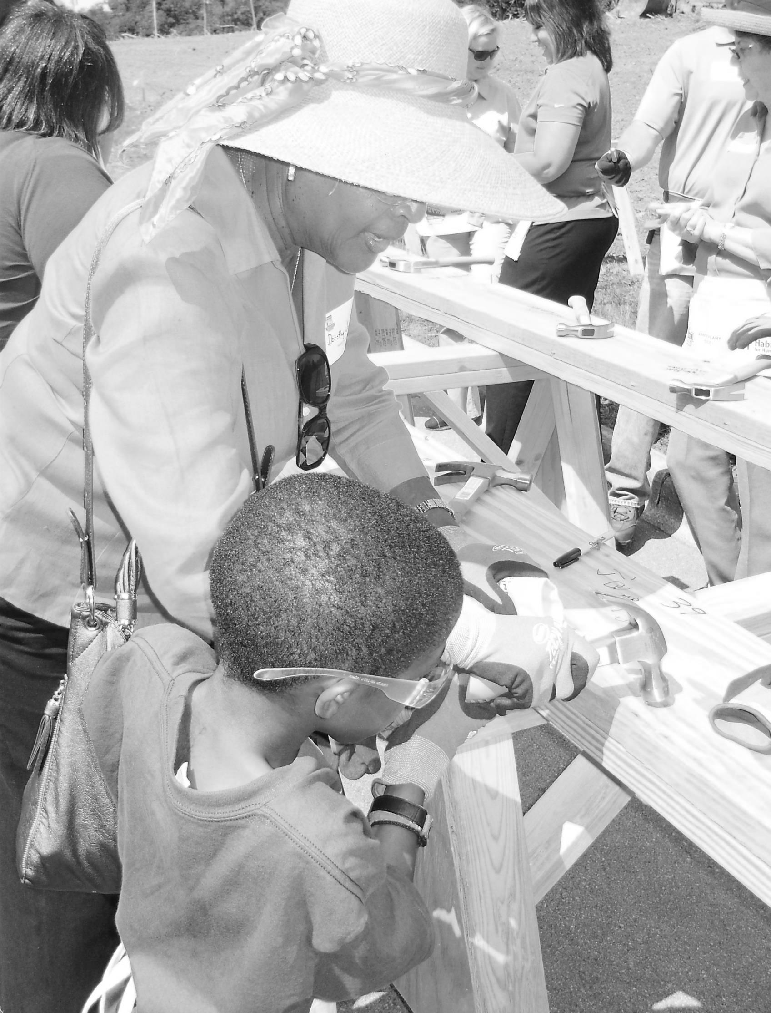

**Table of Contents**

**Partnership: Working Together Page 3**

**Names to Know Page 5**

**Homeowner Education Page 6**

**Phase 1: Homeownership Program Pre-Approval Page 7**

**Phase 2: Loan Pre-Approval Page 8**

**Phase 3: Construction to Closing Page 9**

**Home Design Page 10**

**Construction Page 11**

**Sweat Equity Overview Page 12-13**

**Closing on Your Home Page 14**

**How Your Home is Priced Page 15**

**Homeownership Page 16**

**Partnership Agreement Page 17**

**Frequently Asked Questions Page 18**

**Appendix- Privacy Policy, Grievance Policy, Appendix**

**Construction Waiver, Photo Release, Financial Management**

**Sweat Equity Guide, etc.**

**Partnership: Working Together**

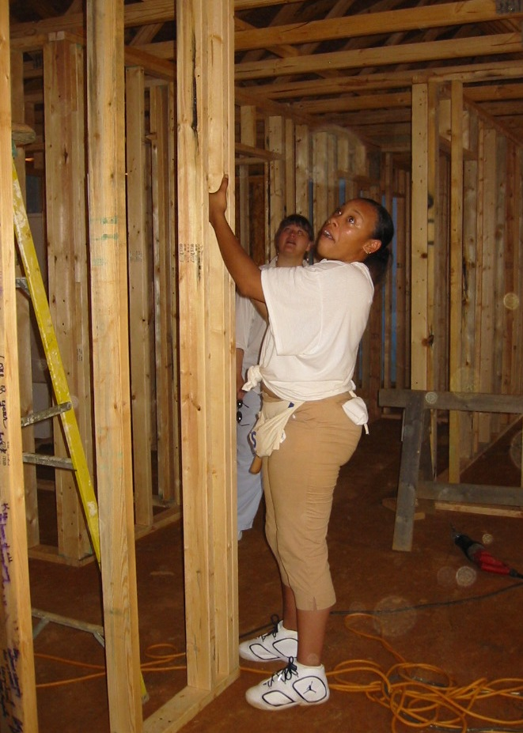Blount County Habitat for Humanity (BCHfH) builds and sells homes to eligible homeowners in the Blount County community. This is made possible with the very hard work of homeowners, volunteer labor, grants, and sponsors. BCHfH does not offer 1st mortgage loans. All BCHfH homes are purchased using affordable 1st mortgage loans from other approved lenders.

Pre-approval for the BCHfH Homeownership Program is **not a loan pre-approval**, nor a guarantee of future loan pre-approval. BCHfH’s Homeownership Program works to prepare applicants for a mortgage loan application and future homeownership. There is a lot to learn and a lot to do as a homeowner. This process will be challenging. The good news is we will do this together as partners.

There are different phases of the homeownership program: Program Pre-Approval, Loan Pre-Approval, and Construction to Loan Closing. The program is completed in 16 months. BCHfH in its sole discretion may change the program timeline or responsibilities when needed.

***BCHfH Responsibilities:***

* Fund-raising necessary to build homes
* Land for construction of a new home, or acquisition of an existing home for rehab, site plans, construction supervision, landscaping and other necessary services
* Homeowner selection based on need for housing, ability to pay and willingness to partner
* Homeowner Education
* Completion and Submission of 3rd party loan application package
* Origination of subordinate forgivable mortgages when necessary to achieve affordability (as outlined by affiliate policy)
* Ongoing support for the homeowner
* Warranty coverage for the house for the period specified by law- 1 year
* Mutual respect

***The Homeowner Responsibilities:***

* Permission to use photos and family information for public relations and fund-raising
* Provide current contact information and family information
* Complete program within 16 months- BCHfH in its sole discretion may change the program timeline when needed
* 200-400 hours of Sweat Equity
* Work at least one day per week on own home
* Setup an Individual Development Account (IDA) and save 1% of sales price as your homeowner contribution (this includes your homeowner’s insurance cost and funding your escrow account at closing)- **Requires instructions from BCHfH**
* Monthly mortgage payments including **principal** and **interest** AND escrow payment of **real estate taxes** and **homeowner’s insurance**
* Select and maintain a homeowner’s insurance policy
* Payment of all other costs associated with home ownership including:
* Utility costs (water, electric, sewage, trash disposal)
* Yard care costs
* Costs of regular and unexpected maintenance
* Completion of regular and unexpected maintenance
* Good care of the property
* Guarantee that the home will be the **Homeowner Primary Residence**
* Be a good neighbor and active member of your community
* Mutual respect

**Homeowner De-selection:**

The failure to complete program requirements is grounds for program removal. A homeowner may also choose to withdraw from the program at any time before closing on the home. Homeowners will not receive payment for any sweat equity hours they have worked. Cause for removal includes but is not limited to the following:

* Failure to complete homeownership program requirements
* Failure to complete the program within the required timeline
* Changes in the applicant’s ability to pay the mortgage.
* Refusal to complete BCHfH Homeowner Education Program (including money management and financial mentoring)
* Failure to follow the homeowner contribution savings schedule
* Failure to complete sweat equity
* Actions that conflict with the mission of BCHfH

The decision to de-select a homeowner is made by the Programs Manager, in partnership with the Director of Programs and the Executive Director, according to affiliate policy.

**Names to Know**

***Executive Director:***

Kathy Jackson

865-982-8717

Kathy@blounthabitat.org

***Director of Programs:***

Sarah Hooks

865-233-9107

Sarah@blounthabitat.org

***Programs Manager:***

Melissa Tyler

865-233-9110

Melissa@blounthabitat.org

***Development Director:***

Vanessa Sparks

865-233-9102

Vanessa@blounthabitat.org

***Construction Manager:***

Doug Jenkins

865-233-9104/Cell: 865-661-3626

Doug@blounthabitat.org

***Home Repair Project Manager:***

Jason Brown

865-233-9103

Jason@blounthabitat.org

***ReStore Manager:***

Fred Plummer

865-379-9299

Fred@blounthabitat.org

***Finance Assistant:***

Lynn Kehn

865-982-8717

Lynn@blounthabitat.org

***Receptionist:***

Rick Page

865-982-8717

Reception@blounthabitat.org

**Homeowner Education**

Every homeowner must complete homeowner education. Homeowners learn about homeownership and money management and begin to earn sweat equity. We want you to succeed, so we will spend a lot of time together preparing for your life as a homeowner.

Homeowners will use the **bi-monthly education calendar, homeowner education syllabus, and the homeowner course tracker** to manage the completion of the education requirements. These resources are provided by and monitored by the Programs Department.

The bi-monthly calendar will be mailed and emailed. **Each homeowner must sign-up for classes** by calling the Programs Manager.

The program has 3 phases to make it manageable for homeowners: Homeownership Program Pre-Approval, Loan Pre-Approval, and Construction to Closing (when you purchase the house from BCHfH).

|  |  |  |
| --- | --- | --- |
| **Phase 1:**  **Program Pre-Approval** | **Phase 2:**  **Loan Pre-Approval** | **Phase 3:**  **Construction to Closing** |
| Courses Required in Phase 1:   1. Welcome and Orientation 2. Money Management 3. Debt Repayment and Management 4. Decision Making and Setting Goals 5. Understanding Credit and Underwriting   Monthly Financial Mentoring  1-on-1 Credit Counseling if required  $90 monthly homeowner contribution  Must complete ReStore hours  Must earn 1/3 of overall required sweat equity. | Courses Required in Phase 2:   1. Homeowner Education Seminar 2. Closing on a Home 3. Homeowners’ Insurance   Monthly Financial Mentoring  Construction sweat equity on other homes  Continue saving $90 monthly homeowner contribution  Must earn 1/3 of overall required sweat equity. | Courses Required in Phase 3:   1. Repairs, Maintenance and Common Issues 2. Yard Care 3. Coping with Hardships and Cost Cutting 4. Selling Your Home   Complete Financial Mentoring  Weekly construction sweat equity on own home  Complete $90 homeowner contribution  Must earn final 1/3 of overall required sweat equity. |

**You are responsible for keeping up with the classes you need. Use the Course Tracker to record classes you have completed!**

**Phase 1- Homeownership Program Pre-Approval (6 months)**

During Phase 1 a homeowner must:

* Complete required Phase 1 Homeowner Education Courses.
  + Applicant and Co-applicant attend required classes. **You must register for each class**.
  + Use the program syllabus and bi-monthly calendar to manage class attendance.
  + Complete homework as assigned.
* BCHfH Money Management and Monthly Financial Mentoring sessions.*
  + Complete Money Management course **within the first month of the program**.
  + Create and follow a spending plan including tracking your spending.
  + Attend monthly financial mentoring meeting.
  + Create and follow a debt repayment plan.
  + 1-to-1 credit counseling if required.
* BCHfH Homeowner Mentoring
  + Available to any homeowner needing assistance managing the program requirements and timeline. Mentors are trained to assist in problem solving and planning for success. These mentors help keep you on track.
* Begin saving 1% of the sale price as your homeowner contribution (approximately $1,350-$1,500).
  + Make monthly **$90 deposits** into your Individual Development Account.
  + Provide monthly proof of deposit to your financial mentor.
  + This will pay your first year’s property taxes and homeowner’s insurance.
  + Any remaining balance after taxes and insurance will be applied to closing costs, then as a principal down payment.
* Complete required ReStore sweat equity hours- See Sweat Equity Policy.
* You may begin earning construction sweat equity on other people’s homes after you complete ReStore hours.
* Programs Manager provides monthly Sweat Equity progress reports.

\***Advancement to Phase 2 is based on individual performance and completion of these requirements.**

|  |
| --- |
| **Phase 1: Program Pre-Approval (6 months)** |
| Courses Required in Phase 1:   1. Welcome and Orientation 2. Money Management 3. Debt Repayment and Management 4. Decision Making and Setting Goals 5. Understanding Credit and Underwriting   Monthly Financial Mentoring  1-on-1 Credit Counseling if required  $90 monthly homeowner contribution  Must complete ReStore hours  Must earn 1/3 of overall required sweat equity |

**Phase 2: Loan Pre-approval (approximately 2 months)**

Families must be ready to submit a loan application **within** 6 months **of signing the Partnership Agreement** or may be removed from the program (exceptions made at the sole discretion of BCHfH)**.** A full mortgage readiness assessment is completed again during this time as well as a review of the homeowner’s performance in the program. This is completed through a series of formal meetings with the Director of Programs and submission of the loan application to the lender institution. The work the homeowner and the Director of Programs will do together has an expiration date. This may require paperwork be completed multiple times and supporting documents renewed.

This meeting is very important because a homeowner cannot move into Phase 3 (Construction to Closing) until this happens. This is known as being **Certified Ready to Build** (CRTB) by the Director of Programs. Once the homeowner is CRTB, they will **choose from properties they are eligible for based on homeowner affordability, build schedule and property investor and/or grant funding requirements.**

If a homeowner “passes” on the available build sites, they move to the bottom of the CRTB eligible list. Homeowners are allowed to pass twice before being removed from the program.

Once the homeowner has been pre-approved for the 1st mortgage, then BCHfH will draft and execute a purchase agreement with the homeowner. This will include the estimated 1st loan, estimated grant award (if available and eligible) and estimated 3rd silent forgivable mortgage from BCHfH.

|  |
| --- |
| **Phase 2: Loan Pre-approval (approximately 2 months)** |
| Courses Required in Phase 2:   1. Homeowner Education Seminar 2. Closing on a Home 3. Homeowners’ Insurance   Monthly Financial Mentoring  Construction sweat equity on other homes  Continue saving $90 monthly homeowner contribution  Must earn 1/3 of overall required sweat equity |

**Families do not necessarily build in order of program pre-approval. A homeowner’s build schedule is based on how quickly the CRTB requirements are completed and their property eligibility.**

**Phase 3: Construction to Closing**

A lot happens in Phase 3. Remember to take a deep breath and we will get through it! Now a homeowner is pre-approved for the loan and **Certified Ready to Build**, has selected the home’s location and is eligible to be on the build schedule. Homeowners will continue to earn weekly sweat equity at their construction site and see their home take shape.

|  |
| --- |
| **Phase 3: Construction to Closing (8 months)** |
| Courses Required in Phase 3:   1. Repairs, Maintenance and Common Issues 2. Yard Care 3. Coping with Hardships and Cost Cutting 4. Selling Your Home   Complete Financial Mentoring  Weekly construction sweat equity on own home  Complete $90 homeowner contribution  Make design and appliance choices  Must earn final 1/3 of overall required sweat equity |

**Home Design**

Before construction begins the homeowner is able to make some decisions about the home design. Please remember, not all Habitat for Humanity homes are the same. We build the best house we can while keeping the homeowner’s needs in mind. Often the home design is determined by characteristics of the lot and the community where it is located. Homeowners will be made aware of these issues as they arise.

**Each homeowner will choose for their own home (from a limited selection):**

* Vinyl Flooring (1 for bathroom and kitchen; 1 for remainder of home)
* Siding Color
* Shutter Color
* Countertop Color

**The basic BCHfH home generally includes*:**

* Approximately 900 square feet for a 2 BR house, 1,070 square feet for a 3 BR house; 1,230 square feet for a 4 BR house
* Steps at all entrances- unless modifications are required by owner
* Front porch
* Concrete steps and retaining wall when necessary
* Lawn graded and seeded
* Uniform semi-gloss enamel paint
* Water heater and furnace
* Low-maintenance exterior siding
* Insulated windows with screens
* Rear storm door
* Stove- white
* Refrigerator- white
* Microwave Range- white
* One full bathroom

**The basic BCHfH home does not include:**

* + Garbage disposal
  + Dishwasher**\*\***
  + Special doors or trim work
  + Ceiling fans
  + Garage or carport
  + Icemaker**\*\***
* Fences
* Washer/Dryer**\*\***

Once the home is complete, the homeowner will be ready to begin the closing process.

*House Design can change as necessary to conform to the neighborhood standards.

**\*\*** May be purchased by the homeowner. Refer to the Certified Ready to Build responsibilities chart.

**Construction**

The construction site is open 3 times each week, depending on weather and holidays. Homeowners must work at the construction site at least 1 day per week while their house is being built.

All homeowners must call the Construction Manager in advance to schedule a construction shift. The homeowner must also call the Construction Manager if they need to cancel. If a homeowner schedules a shift, does not call to cancel and does not show up, then the sweat equity equivalent may be deducted from their total.

|  |  |  |  |
| --- | --- | --- | --- |
| **Construction Site Schedule** (Subject to changes due to Holidays & Weather) | | | |
| Tuesday | Thursday | Saturday | Call to Schedule |
| 8:00 am until midday | 8:00 am until midday | 8:00 am until midday | 865-661-3626 |
| A homeowner must earn 40% of required sweat equity in construction. | | | |

Homeowners should remember that many things impact the building timeline. Weather, volunteers, lender paperwork and grant funding are some of these things. **It is important to remain patient even when there is a construction delay. This is a normal part of the building process.**

**Construction Safety Guidelines**

Families must follow all worksite rules set by the Construction Manager or Construction Supervisor. Every homeowner must sign the Construction Volunteer Liability Waiver form before time on the construction site is allowed. Families cannot work on site if they do not follow the rules.

|  |  |  |
| --- | --- | --- |
| **Bring to the Worksite** (Provided in Homeowner Education) | **Wear to the Worksite** | **Do NOT Wear to the Worksite** |
| Hammer | Sturdy shoes or boots | Jewelry |
| Nail Apron | Clothes that can get dirty | Very nice or dress clothes |
| Tape Measure | Clothes that cover your body | Revealing clothes |
| Utility Knife | Clothes that let you move freely | Open-toed shoes |
| Carpenter’s Pencil | Layer clothes in the winter |  |
| Drink, snack, lunch |  |  |
| **Homeowner Sweat Equity Log** |  |  |

**Sweat Equity Overview**

Homeowners spend time in class, managing money, at the ReStore, helping at special events, building homes, and volunteering in the community. This time is called Sweat Equity. There is no dollar value or refund for sweat equity if a homeowner is deselected or withdraws from the program.

BCHfH requires Sweat Equity for many reasons:

1. Communities and Partnerships work best when everyone plays a part.
2. Builds relationships and creates connections between homeowners, Habitat staff, Habitat volunteers and the community.
3. Neighborhood pride: Helping to construct homes gives a feeling of accomplishment and ownership.
4. It gives the homeowner an opportunity to meet neighbors before they close.
5. Build skills & knowledge to help deal with maintenance and repair issues.

**All sweat equity must be tracked by the homeowner using the BCHfH Sweat Equity log. The homeowner must track, get a staff or site supervisor signature and turn in all Sweat Equity to the Programs Manager each month. The only exception is hours earned at the ReStore- these are turned in by ReStore staff.**

All minors’ school based sweat equity must be documented by a report card or school equivalent and is subject to verification by the Programs Manager.

**See Sweat Equity Chart on the following page.**

**Sweat Equity Overview Chart**

|  |  |  |  |
| --- | --- | --- | --- |
| **Type of Sweat Equity** | **Single Adult Requires** | **Multiple Adult Requires** | **General Rules** |
| Education (includes Library extracurricular or children’s programs) | Homeowner Class  (1:1 ratio per class) | Homeowner Class  (1:1 ratio per class) | 1. ***Homeowners must track and turn in hours monthly*.** 2. Homeowners will get a monthly progress report. 3. Homeowners must complete Money Management and ReStore hours **before beginning Construction**.* 4. Homeowners must **register for construction** by calling the Construction Manager:   865-661-3626.   1. Homeowners must call if they need to cancel, otherwise hours may be deducted. 2. All sweat equity must be signed. 3. Homeowners should keep their own sweat equity records to verify accuracy of BCHfH reporting. |
| Spending Plan Work | Monthly Financial Mentor Meeting and Homework Required (up to 5 hours a month) | Monthly Financial Mentor Meeting and Homework Required (up to 5 hours a month) |
| Homeowner Mentor Meeting | As Needed | As Needed |
| Construction- 40% | 80 hours minimum | 160 hours minimum |
| ReStore (turns in own Sweat Equity Log)- 12.5% | 25 hours minimum | 50 hours minimum |
| Minor School Attendance- maximum 2 children per household | 1 hour every 9 weeks for ≤5 unexcused absences | Same |
| Minor School Grades- maximum 2 children per household | * A Honor Roll=1 hour every 9 weeks * A-B Honor Roll=.75 hours every 9 weeks * B Honor Roll=.5 hours every 9 weeks | Same |
| Don**a**ted- 15% | 30 hours maximum | 60 hours maximum |
| Other | No Limit | No Limit |
| Total Required | 200 | 400 |
| *Special needs of a homeowner will be taken into consideration. | | |

**Closing on Your Home**

Each homeowner will have a Pre-Closing and Closing meeting. The Pre-Closing meeting will make sure the homeowner finished the program, has the chance to ask questions and is ready to take ownership of the home. The Closing meeting includes signing the paperwork with the title company that transfers ownership of the home to the homeowner.

|  |  |  |
| --- | --- | --- |
| **Topic** | **Pre-Closing Meeting** | **Closing Meeting** |
| Homeowner receives a copy of the independent appraisal, loan estimate (7 day wait period) and early disclosures. | X (or by mail if necessary to meet 4 day timeline) |  |
| All BCHfH homes must be the homeowner’s primary residence. This means owners may not rent the home in the future, etc. | X | X |
| Review price of home and mortgage terms. | X | X |
| Final review underwriting- income, debt, etc. | X |  |
| Renew application forms and supporting documents including final credit check. | X | X (if expired) |
| Homeowner’s insurance | Plan for it | Policy Active |
| Arrangements are made to transfer utility service into the homeowner’s name. | Plan for it | Transfer complete within 2 business days |
| BCHfH program requirements complete. | X |  |
| Final Financial Mentor meeting checking spending plan and debt; emphasis on homeownership spending plan. | X |  |
| Closing Disclosure- in person (3 day wait) or by mail (7 day wait) before and at closing | X | X |
| Warranty Deed, Deed of Trust and Promissory Note are signed. | Review Sample | X |
| Homeowner gets the house keys. |  | X |
| All families will complete a “walk-through” home inspection and punch list with the Home Repair Project Manager before the Closing Meeting. | | |

The Director of Programs will schedule the pre-closing meeting and work with the 1st mortgage lender and title company to schedule the closing meeting.

**Families should remember negative changes like an increase in debt or a decrease of income can cause a closing delay. Serious changes can cause a homeowner’s removal from the program.**

**How your home is priced…**

Before a Habitat for Humanity home begins construction the Director of Programs will order an **independent appraisal** of the property. You will receive a copy of this appraisal within 3 days of BCHfH’s receipt. The appraised value will be the “**Sales Price”** of the home. This is what your house is determined to be worth. This must be confirmed by the 1st mortgage lender via their independent appraisal.

With Habitat for Humanity, the sale price of a home can be different than the amount you will pay for the home. The **“Repayable**” mortgage, or 1st mortgage, is based on your affordability. BCHfH defines affordable as 21-25% of the homeowner’s gross monthly income. This is how much the homeowner will pay monthly, **including interest,** over the life of the loan.

Habitat for Humanity may use grants to make the home more affordable if the homeowner is eligible. These grants may be forgiven over time without making any payments. **“Forgivable” Down Payment Assistance (DPA) Grant** mortgage(s) must be repaid if the owner fails to meet the terms of the trust deed, the note or chooses to sell the home before the forgivable mortgage is fully forgiven.

The “Sales Price” minus the “Repayable” and the “Forgivable” DPA equals the **“Silent”** **Equity Subsidy** mortgage. A “Silent” Equity Subsidy mortgage is like a “Forgivable” DPA because you only pay it if you do not adhere to the terms of the “Silent” trust deed and note or choose to sell your home before the “Silent” mortgage is finished**. “Silent” Equity Subsidy mortgages are forgiven by at least $1,000 every year beginning the 6th anniversary in the home**. “Silent” mortgages require written board approval for pre-payment due to refinancing.

There are limits to the value of a “Silent” Equity Subsidy mortgage from BCHfH based on BCHfH policy and costs.

The Director of Programs will review your estimated pricing details when the purchase contract is signed.

Example Sales Price Structure: $135,000

|  |  |  |  |
| --- | --- | --- | --- |
| Contract Sales Price | Repayable Mortgage:  **1st Mortgage** | Forgivable Down Payment Grant (as **2nd mortgage**): | Silent Equity Subsidy (as **3rd mortgage**): |
| Appraisal= **$135,000** | Affordability= **$110,000** | Up to **$14,000** | Appraisal= **$135,000** |
|  |  | Forgiven in 5 years | 1st Mortgage= -**$110,000** |
|  |  |  | Fogivable Grant= -**$14,000** |
|  |  |  | Silent Mortgage= **$11,000** |

Example “Silent” Equity Subsidy Mortgage Forgiveness:

|  |  |
| --- | --- |
| Silent Equity Subsidy Mortgage= $11,000 | |
| Yearly Forgiveness Begins on 6th anniversary  $11,000/$1,000 minimum forgiveness = 11 years | **Term**: We wait 5 years before forgiveness begins  11 years+5 years= Mortgage Term 16 years |

The Mortgage Servicer for each loan will complete a **Pay-off Statement** if you choose to sell your home before the “Repayable” mortgage is finished. The Pay-off statement is how much must be paid to the Mortgagee and Habitat for Humanity. The homeowner will request and receive a pay-off statement for **each loan**, including **any remaining** “Forgivable” and/or “Silent” mortgage balances that have not been forgiven yet.

**Homeownership**

Congratulations, you are now a homeowner! Homeowners must make monthly mortgage payments to a mortgage servicer selected by the lender. **The monthly payment is the principal, interest, taxes and insurance or PITI.** The tax and insurance money is deposited into the homeowner’s escrow account for those yearly bills. The servicer will pay the yearly property taxes and homeowner’s insurance on the homeowner’s behalf using the money in the homeowner’s escrow account (other bills like homeowner’s association dues can be escrowed).

The homeowner’s insurance premiums and property tax bill are very likely to change on an annual basis. The homeowner’s PITI will change due to the annual escrow analysis performed by the mortgage servicer. It is important for homeowner’s to remember, the principal and interest portion of the payment will not change, even when the taxes and insurance portion of the payment does change.

**Homeowners are responsible for the repair and upkeep of the home.** This includes the regular care of the yard and the storage building. A home is the largest investment most people will make, so it is important to take care of it.

The BCHfH and Homeowner partnership will continue during homeownership. Homeowners agree to have the home as the primary residence while they own it. This is included in the closing paperwork homeowners sign. This is not negotiable within the Habitat for Humanity program.

Homeowners must contact the Mortgage Servicer if they cannot pay the mortgage or decide to make changes to the homeowner’s insurance selected. Monthly payments and insurance are required. The lender may take back the house through foreclosure if the mortgage is not paid, homeowner’s insurance lapses, the house is not the primary residence or the homeowner does not take care of the home and yard.

If a BCHfH homeowner chooses to sell the house they must offer it to BCHfH first. Habitat will have the right to buy the home at the price negotiated with another homeowner. This is called the Right of First Refusal.

Refinancing the silent subordinate mortgage held by BCHfH (a 0% interest mortgage) with an interest-bearing loan requires BCHfH Board approval. This is not allowed by some mortgage investors or grants used by BCHfH.

Each lender chooses a company to service the loan they own. The owner’s 1st mortgage lender will service and bill the owner separate from subordinate loans owned by BCHfH. All Blount County Habitat for Humanity subordinate mortgages are currently serviced by FAHE, Inc.

BCHfH’s servicer will send the homeowner an annual statement regarding the status and balance of the BCHfH silent subordinate mortgage. This balance is owed to BCHfH if the home is sold or the Trust Deed violated.

***Partnership Agreement:***

**Each Adult must initial each statement:**

|  |  |
| --- | --- |
|  | I acknowledge I have read and understand this Partnership Manual as my Partnership Agreement with Blount County Habitat for Humanity. By signing this Partnership Agreement, each adult member of the homeowner household acknowledges that they have had an opportunity to ask questions, have had a full and complete explanation of each element of this agreement and accept each condition noted herein. The failure to comply with the Partnership Manual is grounds for removal from the program. |
|  | I acknowledge that I have read and understand the Sweat Equity policy contained within this Partnership Agreement. I further acknowledge that I understand how Sweat Equity hours are earned, the penalties that may be imposed for my failure to meet my responsibilities and how the failure to fulfill my responsibilities can result in my removal from the program. Finally, I understand there is no dollar value or refund for sweat equity if I am deselected or withdraw from the program. |
|  | I acknowledge that I have read and understand the Education, Money Management, Mentoring and CRTB Policies contained within this Partnership Agreement. I agree to the outlined expectations and recognize that violation of this policy may result in my removal from this program. **I further understand and acknowledge I will choose only from select, eligible properties based on my affordability, investor and grant funding requirements once I am CRTB.** |
|  | I acknowledge that I have read and understand the Blount County Habitat for Humanity Construction Policy contained within this Partnership Agreement. I agree to the terms of the policy and recognize that its violation may result in my removal from the program. |
|  | I acknowledge that I have read and understand the Blount County Habitat for Humanity Home Pricing and Servicing Policy contained within this Partnership Agreement. I understand BCHfH does not make 1st mortgages and 0% interest 1st mortgage loans are not available through BCHfH. ***I understand the home must be my primary residence while I own it. I know this is not negotiable within the Habitat for Humanity program.*** I agree to the terms of the Home Pricing and Servicing Policy and recognize this as a core part of the Habitat for Humanity Homeownership Program. |
|  | I acknowledge that I have read and understand my pre-approval letter including the 8 month expiration and underwriting conditions contained within. I further acknowledge the 8 month requirement can change at the sole discretion of Blount County Habitat for Humanity. |
|  | BCHfH is a non-profit dedicated to the vision of a world where everyone has a decent place to live. BCHfH will do its best to comply with the responsibilities and program description outlined in this manual. However, BCHfH cannot make a guarantee regarding contents of this manual due to factors that may be outside of BCHfH’s control. |
|  | BCHfH in its sole discretion can alter the existing partner agreement and partner manual as it deems necessary. |

In witness whereof this ______________________________day of____________________________, 20_______.

**Blount County Habitat for Humanity Habitat Homeowner**

|  |  |
| --- | --- |
|  |  |
| **Director of Programs** | **Applicant** |
|  |  |
| **Programs Manager- Witness** | **Co-Applicant** |

***Frequently Asked Questions (FAQ)***

1. Does BCHfH offer 0% interest loans to purchase homes?

No. BCHfH has transitioned to a 3rd party lending system for 1st mortgages. Our lending partners do charge interest, but BCHfH does ensure the mortgage you apply for is affordable. BCHfH works with homeowners to prepare them for the loan application and assist in the approval process.

1. I am a single parent, but I have a child that is 18 years old. Am I considered a single adult home or multiple adult home?

You are considered a multiple adult home, **if the 18-year-old has graduated high school**. An individual is considered an adult at 18 years of age; anyone in the home that is 18 or over is considered an adult and should help contribute to the sweat equity.

1. What if I schedule time and I do not show up?

We understand things happen. We ask that you let us know if you cannot make it so we can plan the day accordingly. If you do not show up, and you do not call, you may be docked an equivalent amount of hours you were scheduled to work.

1. May I bring people to the worksite with me?

Yes. You must let the Construction Manager know how many people you would like to bring to the site when you call in advance of the workday. Each volunteer must sign a waiver and be 16 years old or older. Minor volunteers require a minor waiver signed by the parent or guardian.

1. What time does the workday begin?

The construction workday begins at 8:00 am and ends at midday- unless otherwise noted due to weather or holiday.

1. May I sell my home?

Yes, you may. Once we close on your home you are a homeowner. Your house is used as the collateral for the loan needed to pay for your home. This does not prevent you from selling your home at any point you choose. You must pay your mortgages through the sale of your home. This includes any remaining balance on the silent, forgivable, subordinate mortgages.

1. Will my mortgage be the amount listed on my pre-approval letter?

No, not necessarily. We will not know the actual value of your mortgage until you have been Certified Ready to Build, a second underwriting is complete, you are pre-approved by the 3rd party lender, and we have an independent appraisal completed for your future home. An estimated mortgage package will be presented to you at that time. This may still change if your income or credit worthiness changes before closing.

1. May I use my house as a rental house?

No, you may not. All Blount County Habitat for Humanity homes must be the homeowner’s primary residence. Homes may not be used as a rental or vacation property at any time during the repayment of your mortgage.

Appendix

1. Privacy Policy
2. Email and Text Permission Form
3. Grievance Policy
4. De-selection Policy
5. Withdrawal Request Form
6. Construction Waiver
7. Photo Release
8. School District Preference
9. Financial Mentoring Performance Report
10. Education Syllabus
11. Education Course Tracker
12. Sample Home Construction and Sales Agreement
13. Investor-Funding Agreement Addendum